

Mauli Rituals:
Making the Ritual the Unit of Future of Commerce
Course: The Future of Commerce
Student: Adar Akşak, Ali Sarp Acar, Kartavya Jharwal, Marcella Ibanhez,
Olta Abdyli, Yasmim Morais Souza and Zuzanna Zalicka
Professor: Nikhil Soi
Date: 17/10/2026
Word Count: 2100



Prologue
Anita and Bittu Kaushal lost their daughter in 2012 to a brain tumour. The girl's life aspiration was to develop a feeling of connection and confidence in her own life surrounded by people. In 2015, using a family history that included many generations of Ayurvedic practitioners, herbalists, midwives, and plant medicine growers, the couple founded Mauli Rituals. Each box contains a blessed red mauli thread, a symbol of protection, connection, and caring. It is not just decoration but rather the very mechanism of evolution of the brand (Mauli Retailer Deck, 2026; Mauli Rituals Playbook, 2026).
The strategy for growth implies the shift from a fragmented layer of knowledge and consciousness to a controlled, machine-readable source of truth, which guarantees correct and efficient access to information and activation through artificial intelligence. Moreover, it involves separating bounded Ayurvedic quiz logic from conversational interaction.
The success would not only rely on the reach at the top-of-funnel and the quick category development but rather on customer continuity, ritual repetition, and flawless digital representation of the brand.

Table of Contents
Prologue 2
Table of Contents 3
Recommendation 5
Diagnosis 5
Proposal 6
Roadmap: first 12 months 7
Metrics 7
Exclusions 8
Evidence and Limits 8
Conclusion 8
Appendix A 9
A1. Quiz & Ritual Builder walkthrough 9
A2. How Mauli appears in generic searches 10
A3. AI delivery recommendations 11
Appendix B 15
B1. Purpose, method and scoring 15
B2. Limitations and repeat protocol 16
Appendix C 16
C1. Strategic measurement 16
C2. AARRR KPI tree 17
C3. Evidence and assumptions 18
Excel model link 18
Appendix D 19
D2. Evidence from comparable brands 19
D3. Ritual Profile pilot (90 days) 19
D4. How initiatives scored 20
D5. Client data request 20
Appendix E 20
E1. Programme benchmarks 20
E2. Design 21
E3. Pilot and measures 21
Appendix F 21
F1. Interpretation 22
F2. Recurring formats 22
F3. Journey and measure 22
Appendix G 22
G1. Supporting diagnostics and running the scorecard 23
References 25
Team Contributions and Use of AI 27

Recommendation
Redefine the ritual as a prospective unit of commerce for Mauli: make the ritual precede product diversification. AI should perform the ritual according to plan, human voice should inform of the ritual existence, and sustainability and profit should be used as success measures, rather than visibility. In this conceptualization of the marketing model, there is no intention of creating another identity for Mauli. The goal is finding a replicable model that retains the image of the brand in diverse technologies, channels, and products.
Insight: To maintain a premium brand position, one needs to preserve a single meaning system, instead of multiplying messages (Lemon & Verhoef, 2016). Consistency does not contradict customer acquisition because small brands grow through acquiring customers (Sharp, 2010).
Accordingly, it can be argued that the ritual would reduce the costs of customer acquisition and retention for each new customer. For example, in the case of Stitch Fix, the customer satisfaction was reached with the help of personalized quizzes at 86%, whereas marketing costs were only 3%–7% of revenue (Goodwater Capital, 2017). The study reveals that Mauli appears more prominent in prompts about Ayurveda or dosha, compared to general ones.

Diagnosis
The challenge faced by Mauli is how to make its rituals clearer, more accessible and more repeatable but at the same time keep their meaning and operate within the team's capabilities. The power of the organization lies in the interaction of Ayurvedic wisdom, founder's authority, sensory practice and the sacred thread of Mauli. As a result, the products are both useful and culturally and symbolically valuable (Oswald, 1999; Mauli Rituals, 2026a).
Representation gap: artificial intelligence does not properly represent Mauli at the moment. In the team's ten-product audit, Mauli was mentioned more often when prompting the terms of Ayurveda, dosha or Vata than when prompting broader categories. AI assistants provided inaccurate prices and unfounded claims (Mauli Rituals team, 2026a; Appendix B). Mauli needs one source that will contain all accurate information about products, rituals, availability and claims.
Recommendation gap: the quiz is not connected to real inventory. On 6 October, the Ritual Builder recommended The Complete Kansa Gift Set, but the basket then marked it as sold out (Mauli Rituals team, 2026c; Appendix A). It is one observation that does not imply a failure rate; however, it demonstrates the need to connect ritual recommendation with live inventory levels.
Education gap: novice customers get the results before getting enough explanations. The quiz recorded ends with the brief ritual description, leaving little space for education on Ayurveda and doshas (Mauli Rituals team, 2026d; Appendix A). The proposed agent, Vay, should educate on Vata, Pitta and Kapha as traditional types of mind-body, ask about your physical type and everyday disposition and demonstrate how it influences the choice of ritual. However, it is educational advice and not a diagnosis.
Economic gap: repeat purchasing should be accounted for in the model. Direct to consumer sales make 61% of total business, and the founder says that discounts and advertising bring the first order close to break-even (Mauli Rituals, 2026a, 2026b). Meta ROAS fell from 2.57 to 1.56 in a dataset from February 2024 to April 2026 of one agency that deals with more than 230 brands (Common Thread Collective, 2026). 54% new-to-returning customer split is not a cohort-based repurchase rate. Hence, Appendix D and unit-economics model should explore how the change in repurchase rates would affect contribution and acquisition payback.
Measurement and capacity gap: attention is not the same as sustainability. Instagram followers number increased from around 36,000 to 105,000, but Mauli itself managed to reach median audience of around 2,500 people, out of 69 million views, 93% were provided by 20 reels, and none of the 18 most viewed posts were about products (Mauli Rituals team, 2026b; Appendix F). Email open rate of 77% is higher than the 30.5% industry average for health and beauty sector; however, Apple Mail Privacy Protection can increase the number of opens (Klaviyo, 2026; MarTech, n.d.). Moreover, AI-generated summaries seem to reduce clicks to regular results, falling from 15% without summary to 8% with one (Pew Research Center, 2025). Therefore, the KPI framework should translate AARRR metrics to contributions depending on factors like reorder from partners, inventory levels, fulfillment and team capacity.

Proposal
Move | Changes Impacted | Brand safeguard
AI personalisation: Master Truth & Ritual pages. Publish a central repository of context and one approved page per ritual and product with structured data, through the new shopify universal commerce protocol for agentic commerce. (Shopify, 2026; Let's Data Science, 2026). | Brand Strategy,  Source of Truth  Positioning, Catalogue | Each ritual should exist as one approved, reusable information record containing its intended purpose, dosha relevance, ingredients, sensory descriptors, ordered steps, associated products, current prices and availability, permitted claims and founder or practitioner approval. An approved-claims file rules out wording such as "scientifically proven" (CTPA, 2026).
AI personalisation: Voice and Sound engineering. Pilot through ElevenLabs Vay an optional voice-guided ritual journey and quiz, starting with recorded founder articulations and phrasing guidance and progressing to a clearly disclosed synthetic voice interface where it provides measurable value. Voice backed by crafted sensory sound should help customers be educated on ayurveda, follow the quiz deeply, experience an understanding of the brand and return to the practice of the ritual. | Customer experience | No unauthorised founder voice cloning, invented product claims or health diagnosis. Sensitive questions are transferred to a person. Compare voice-guided and text-guided journeys on completion, trust, conversion and subsequent ritual use. Utilise ElevenLabs prompt injection prevention and guardrails to further protect the systems.
AI personalisation: a quiz that chooses and explains. The quiz schema chooses products from inventory through shopify universal commerce protocol. An initial discovery call from the Vay agent passes on a validated schema of data that the decision model runs analysis on top of, ensuring a visualisation of how a vaidya would pick from a box of botanicals. | Customer experience | AI cannot add, remove or reorder products and uses no health language. Health questions go to a person. The team reviews text weekly at launch. A privacy note sits before the email step, checked against UK GDPR.
AI personalisation: Ritual Profile. Store each customer's dosha and main concern. Send three post-purchase email journeys (Vata, Pitta, Kapha) ending in a reorder prompt timed to when the product runs out. In health and beauty, automated emails like these earn about six times more revenue per recipient than one-off campaigns ($2.09 against $0.32) (Klaviyo, 2026). Run for 90 days with about 20% of eligible customers held back as a control. | Customer experience | Anita records the content. The profile is optional, and customers who skip it still receive general Ayurvedic education. The reorder prompt carries no discount.
Pricing: value-led offer test. In one of the two 20% sales, offer a ritual set or gift with purchase to part of the audience and compare profit per order and repeat rate with the 20% offer. | Pricing, merchandising | No competing on price in AI comparisons, and no false urgency or misleading reference prices (Gowling WLG, 2026).
Social and live: community formats. Run three weekly formats: "Ask Anita", "Ayurveda Did It First" and "Return to Self". Every high-reach post links clearly to Mauli and the quiz, so Instagram is the entry point to the ecosystem and not the whole of it. | Positioning | Real people only: Anita and verified practitioners. No synthetic voices, influencers or testimonials.
Social and live: practitioners. From month six, verified practitioners lead live rituals. A private professional area offers approved therapists a replenishment subscription, piloted with therapists who have already asked to buy. | Merchandising, pricing | A person checks qualifications and insurance (Eve Taylor, n.d.). Formulas and ritual guidance stay unchanged. No public booking marketplace. Prices follow volume and cost to serve.
Voice: recorded, not synthetic. Add short recorded clips of Anita and practitioners to ritual pages and quiz results, and write short FAQ answers so voice assistants read the facts correctly. | Customer experience | Real recorded voices only. Any synthetic voice is disclosed, limited to reorder reminders and never copies Anita's without her written consent.
Margin is also not a criterion for the product. Once the products are discovered, the decision engine will rank the products based on energetic fit, margin, and stock. Mauli will retain both fit and stock in the results of the quiz but will not consider margin. Considering margin will make Mauli sacrifice formulas at the expense of margin, which would introduce a margin bias and kill confidence in the quiz results. Margin is used in the offer of ritual sets by Mauli but not in the product recommendations to the customer.

Roadmap: first 12 months
0-3 months: Baselines development using client data, audit claims, feed/price structure adjustment, linking of the quiz to actual cattle, starting monthly and weekly Ask Anita AI assessment.
3-6 months: Release ritual pages, add AI-based explanation of the quiz, release Ritual Profile pilot and community format, release practitioners.
6-12 months: Live rituals performed by practitioners, new user chat with customer questions, budget redirection from non-driving elements (Appendix G).

Metrics
North star: re-ritualized clients – those buying a whole ritual and coming back within six months. This single metric encapsulates everything in the process: find, select, retain. Baseline will be established using customer data, and our current repeat rate is 54% (Mauli Rituals, 2026b). Table 2 provides a single headline metric for each journey stage, to be analyzed each month together with Anita.
Table 2
Scorecard for Mauli Ritual
Stage | Headline metric | Currently | One-year target
Identification | General AI visibility: ten questions each month in ChatGPT and Gemini, then in Perplexity and Google AI Mode, each multiple times per month | Cited in 2 of 8 category discovery answers, and 6 to 7 of 10 overall | Above baseline for each monthly check
Description | Accuracy of AI: wrong prices and claims not on site | Gemini: 1 wrong price, claims that are not supported in 7 of 10. ChatGPT: prices accurate in 5 of 5 | No wrong prices or unapproved claims
Selection | Conversion rate from quiz-to-ritual purchase within 30 days | Needs client data. One sold out recommendation seen | Baseline in month 1, rising thereafter, with no sold out recommendations
Retention | Repeat rate | 54% | At or above 54%, even as new channels launch
Delivery | Rate of Ritual Participation: opted-in members with two or more meaningful Mauli experiences per 30 days | Not yet tracked | Baseline at launch, rising each quarter
Note. Audit metrics are from Mauli Rituals team (2026a).
Pilot performance is measured individually: for the Ritual Profile pilot, the measure is the ritual adoption rate (consumers who buy a second dosha ritual in the following 90 days), while for the therapist pilot, it is subscription conversion or renewal success. The scorecard needs to become a decision-making system rather than a dashboard. In e-commerce analytics literature, it is stressed that the integration of information, processes, and decision-making capabilities is crucial (Akter & Fosso Wamba, 2016).

Exclusions
- Growth in followership or going viral. This will be useful in creating an audience for Mauli, which they cannot interact or sell to.
- Influencer content generated through artificial intelligence. Mauli will require actual people.
- Retailer listings under the present circumstances; listings on TikTok/marketplace. Large margin profits, but the network will put extra stress on the workforce than the team size can accommodate.
- Therapist marketplace publicly; automated process of listing therapists. This will compromise quality and branding at the initial stage.

Evidence and Limits
Mauli figures are mostly stated by the founders and are unaudited. The first-order contribution margin figures are not available yet. The assistant audit is based on one execution of ten prompts per each assistant using default parameters, while the quiz walkthrough was performed in one session only, thus none of these procedures provides us with any information on how often the problem occurs. The Instagram figures are obtained by the team through its analysis of the content; the methodology used by the team is outlined in Appendix F. Figures on voice and decision-making model are provided by vendors, with some benchmarks from the US included.

Conclusion
The team envisions a Mauli that grows beyond the boundaries of beauty, where new categories, technologies and experiences become different expressions of one enduring philosophy. Its future need not be defined by it’s presence on agents and chatbots or the products it creates, but rather by the meaning it preserves for its guests and the possibilities it opens for partners. From an Indian-rooted ritual brand to a globally recognized authority on modern wellbeing, Mauli has the opportunity to shape not just what people buy, but what they return to when they think of ayurvedic rituals. Our north star is a future where Mauli is a ritual they choose to carry through life.

Appendix A
Ritual Builder Walkthrough and AI Delivery Recommendations (Q1 and Q2)
This appendix supports the diagnosis in the main report.It covers the walkthrough of the Ritual Builder quiz on 6 October 2026, explains why they matter strategically, and restates the three recommended changes in a form that matches the proposal rather than fragmenting it across notes.
Table A1
Appraisal of Emerging Technologies for Mauli Rituals
Option | Carries the senses? | Reaches new people? | Affordable and controllable? | Evidence grade | Verdict
Richer quiz with sound, colour, branching and a full result | Partly (sight and sound) | Yes, through search and shares | Yes, on the existing platform | Moderate; length effect a hypothesis | Year one, test paths
Structured ritual data for AI assistants | Not applicable | Yes, through assistants | Yes, low cost | Moderate; crawl is vendor-graded | First priority
Sensory film on product and ritual pages | Partly (sight and sound) | Yes, when shared | Yes, with own footage | Hypothesis | Year one, test
Decision layer (Jev, with Clef as benchmark) | Not applicable | Indirectly, through routing quality | Yes, with a wrapper and fixed options | Vendor-reported only | Pilot now
Brand-knowledge agent for newcomers | Not applicable | Yes, if accurate | Only after content and logs exist | Hypothesis | Later
Voice assistant with ElevenLabs | Partly (sound) | Limited for a considered purchase | Needs checks on data and pricing | Vendor documentation only | Later, reorders only
AR try-on | No (cannot carry scent) | Limited | Costly relative to benefit | Moderate; applies to eyewear | Not now
VR or metaverse retail | Limited | No evidence | No | Roadmap only | Not now
Digital scent | Would carry scent | Not in market | No | Roadmap only | Watch

A1. Quiz & Ritual Builder walkthrough
The quiz runs on a separate address (mauli.ecrubox.com) and is a custom Shopify app built by Ecrubox. It recommends products with fixed rules, not AI or representative of inventory.

A1.1 Quiz diagnostic comparison
The team recorded the Harry Potter house quiz and Mauli's own quiz (Mauli Rituals team, 2026d). The Harry Potter quiz asks for a sign-up first, takes about six and a half minutes, uses colour, art and sound, branches on earlier answers and ends with a detailed result. Mauli's quiz takes under a minute, has no sound or motion and ends with one sentence about the ritual. Both observations come from one recording and should be re-checked. The course argues that shoppers share data when the benefit is explicit, immediate and proportionate (Future of Commerce course materials, 2026a). The implication is to make the result richer, not to add a sign-up wall: describe the ritual's steps, scent and texture in plain words, show the product in use, and ask for email after the result. The best quiz length is an open question, so a short path and a full path should be tested against each other.

A1.2 Walkthrough errors
In the walkthrough the issue is recommendation integrity at the point of selection. In the walkthrough on 6 October 2026, the Ritual Builder recommended The Complete Kansa Gift Set at £244 and the basket then flagged it as sold out. The walkthrough was only one observed session, so frequency is unknown, but the failure matters because it occurs at the exact moment the customer is ready to convert.
Figure A1
Ritual Builder Result With The Complete Kansa Gift Set (£244) Shown as Selected
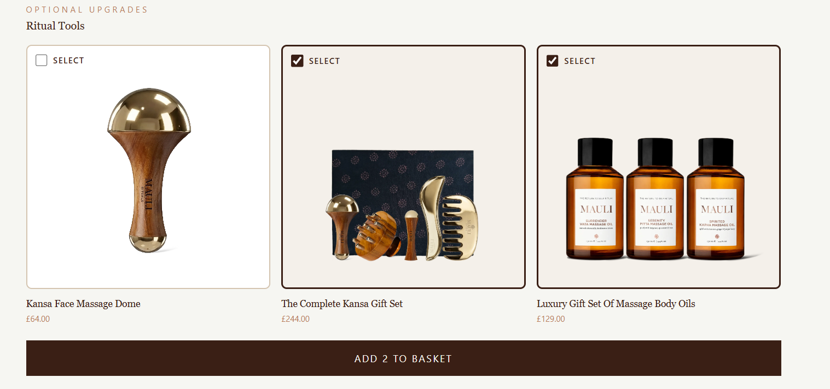
Figure A2
Checkout Message: The Complete Kansa Gift Set Is Sold Out and Will Be Removed From the Cart
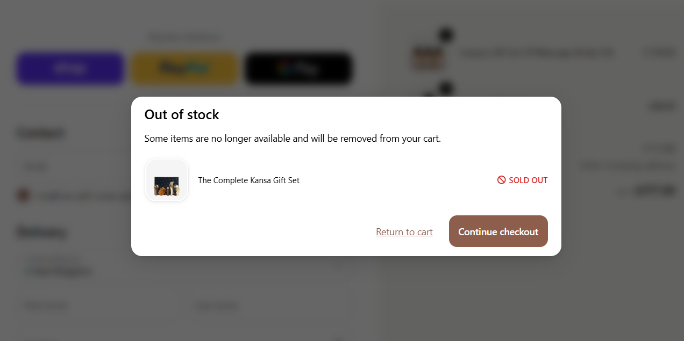

A2. How Mauli appears in generic searches
. In the team’s audit of ten shopper prompts, Mauli appeared more often when the prompt used Ayurvedic language such as dosha or Vata than when the shopper used generic category language. More on context in Appendix B.
Two Google searches for generic category terms, "product ayurveda" and "natural cosmetics", were captured. In the parts of the results captured, the related searches name other retailers (for example Holland & Barrett) and generic terms, and none names Mauli.
Figure A3
Google Results for "product ayurveda"
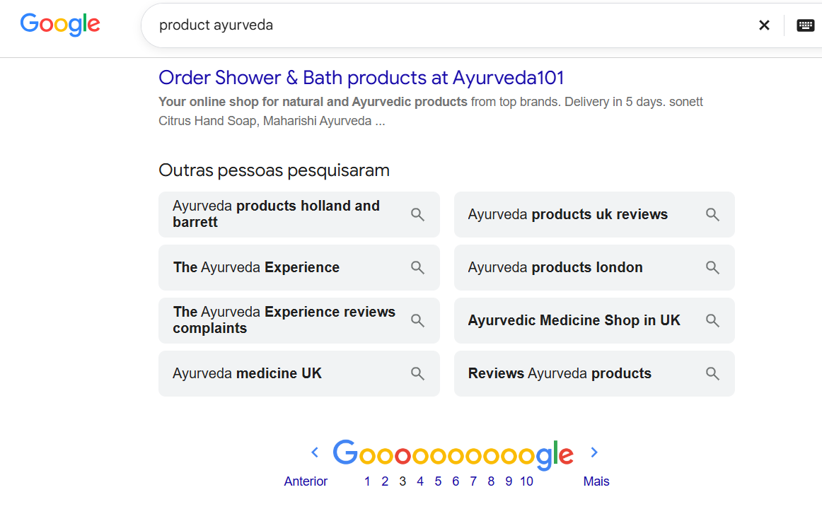
Figure A4
Google Results for "natural cosmetics"
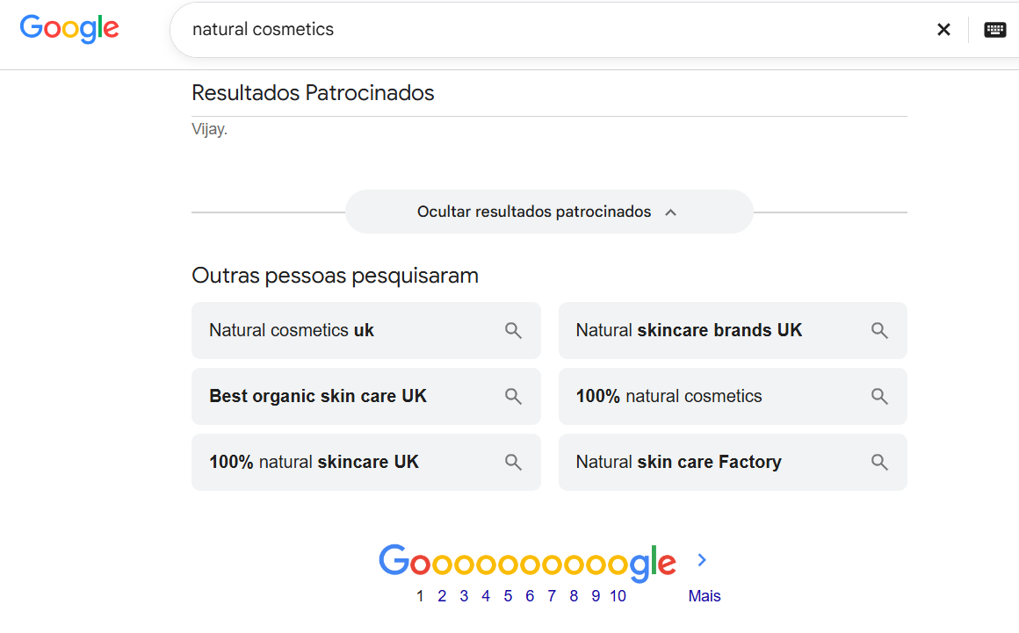

A3. AI delivery recommendations
These observations point to a single underlying problem: Mauli’s core value is legible to people, but not yet governed well enough for machines, assistants and downstream interfaces. The issue is not that AI is inherently unsuitable for Mauli. It is that, in the absence of a controlled source of truth and a bounded recommendation architecture, generic AI systems will either underspecify the brand or overstate it.
That is why the response should not be a generic chatbot or a looser layer of generative content. The proper response is architectural. Mauli needs to govern what machines can retrieve, what the recommendation system is allowed to decide, and how sensory richness is expressed at the interface. The three changes below are therefore not separate experiments. They are three layers of the same operating logic.

A3.1. Change 1 GEO & AEO and source-of-truth pages
The first change is to create a governed source of truth for rituals and hero products. Each ritual should exist as one approved record containing its purpose, dosha relevance, ingredient logic, sensory descriptors, ordered steps, associated products, live price and availability, permitted claims, and founder or practitioner approval. That record should then feed public ritual pages, product pages, structured data objects and agent-facing commerce surfaces.
This change matters because retrieval now happens before the click. If Mauli does not publish governed records in machine-readable form, answer engines and agents will reconstruct the brand from incomplete signals. Structured ritual pages, approved claims language and structured data therefore matter more than generic AI-facing files alone. The objective is not simply better SEO. It is more faithful retrieval across search, answer engines and emerging agentic commerce.
Operationally, this change includes three immediate actions:
- Rewrite the current generic AI-facing text in Mauli’s own governed language.
- Publish approved ritual and hero-product pages with structured data.
- Confirm how product and price feeds are currently maintained so that downstream machine-readable surfaces reflect live truth.

A3.2. Change 2 - Vay AI Agent
The second change is not “add voice AI” in the generic sense. It is to build an optional voice-and-sound layer that sits above the governed source of truth and makes the ritual more legible, memorable and distinctive in digital form.


The Vay agent is set up as a conversational discovery and diagnostic intake guide for Mauli Rituals, rooted in classical Ayurvedic principles.
- Role and Purpose: Configured as an intake guide focused strictly on assessing energetic states (Vāta, Pitta, Kapha) and recording visitor wellness concerns without pitching products directly.
- Procedures: Includes an active free-form procedure for Ayurvedic Dosha & Lifestyle Assessment to structure the diagnostic discovery flow.
- Data Collection and Evaluation: Configured with 6 extraction fields (guest name, contact, location, skin profile, energetic state, and wellness concerns) and 4 post-call evaluation criteria.
- Testing and Iteration: Backed by 4 attached simulation tests and 7 committed versions tracking its evolution from initial creation to a focused intake and assessment guide.
The strategic point is that voice should not be treated as a weak substitute for in-person brand value. Poor implementations feel generic because they are badly designed, not because voice itself is incapable of carrying premium meaning. In Mauli’s case, sound design, with layered chants and sonic tones, can function as a sensory extension of the brand: shaping cadence, emotional texture, memory and ritual pacing when scent and touch are absent.
This means the correct voice design is bounded and staged. It begins with Anita and Bittu's founder diction and articulation, approved phrasing and guided ritual explanation. It then extends to clearly disclosed synthetic delivery through only where it improves completion, guidance or reorder behaviour. Prompt-injection resilience and guardrails belong here as technical requirements, alongside claims control and human escalation. The recommendation is therefore pro-voice but anti-generic-voice. The value lies in a sensorially engineered interface that enriches the ritual while leaving recommendation authority, claims and stock truth elsewhere in the system.

A3.2.1 Ayurvedic Dosha & Lifestyle Assessment Procedure
When the guest is ready to explore their wellness, shares symptoms, discusses Ayurvedic dosha balance, or completes their intake assessment.

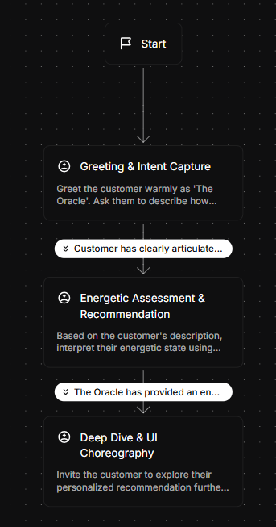

Context & Scope
Perform an intake and observation consultation using the THREE classical doshas only: Vāta, Pitta, Kapha. Do not introduce other energetic terms.
CRITICAL RULES:
Classify observations strictly under Vata, Pitta, or Kapha (or a combination of these three).
DO NOT recommend, name, or pitch any products, oils, salts, or botanicals. Downstream recommendations happen inside the web application.
EXCAVATE the four intake answers. Tenaciously guide the conversation back to the discovery questions. If the user drifts to another topic or asks for recommendations, briefly acknowledge, then pivot straight back to the next missing intake question.
Intake Fields to Excavate
Current physical/mental state (sleep, fatigue, stress, muscle tension, temperature).
Skin profile (texture, moisture balance, sensitivity).
Geographic / regional climate.
Guest name and email.
Step-by-Step Flow:
Step 1: Connect & Begin Excavating
Greet the guest and ask how they are feeling today.
If the response is vague ("I'm fine", "just browsing"), excavate: ask about a specific sensation (sleep, energy, stress, temperature).
Step 2: Observation, Skin & Geographic Context
Walk through each remaining intake field with one focused question at a time
Reflect each answer back as Vata, Pitta, or Kapha (never other terms).
If the user asks about products or drifts off-topic, say something like "I'll make sure the web app has what you need for that — first, let me finish excavating a couple more details," then return to the next missing field.
Step 3: Contact Capture
Gather name and email for their record. If they hesitate, explain the record is required for their personalized profile and ask again
Step 4: Profile Delivery & Immediate Conclusion
Deliver a clear summary of their skin and three-dosha energetic profile.
Introduce the 'Eternal Jukebox' interactive chord visualization as their next step in the web application.
Deliver an explicit warm closing sign-off and immediately end the conversation. Do not prolong or add further explanations after this sign-off

A3.3 Change 3 Aushada Peti - The Sacred Wheel of Botanicals
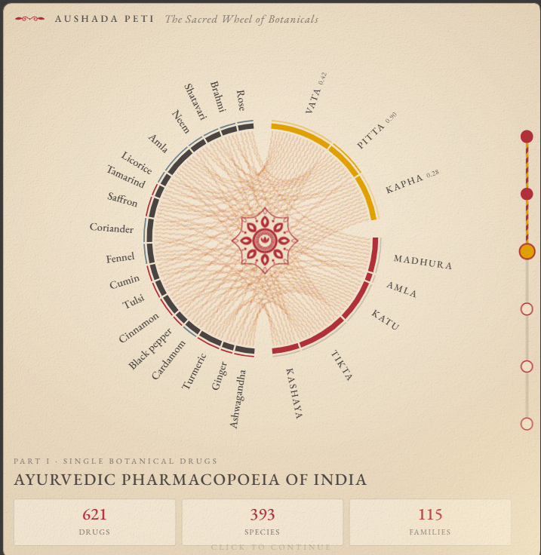
The third change is to keep the act of recommendation bounded.
Aushada Peti, titled The Sacred Wheel of Botanicals, is an interactive digital MVP demo rooted in Ayurved, botanical pharmacopoeia, and constitutional doshas. The platform centers around an interface with a circular chord diagram that visually connects botanical ingredients to specific tastes and constitutional types. Users can explore detailed botanical properties, select preferred herbs, and view ranked recommendations for custom herbal blends. Behind this UI, Vay uses data from the initial discovery call to run a data validation and decision model, identifying the optimal custom mixture in the manner of an experienced Ayurvedic practitioner.
To eliminate stock integrity and hallucination risks, the post-discovery process avoids using a general language model LLM to invent results. Instead, it converts customer inputs validated by schema handoffs into approved dosha, ingredient, and product logic, returning only valid options from live inventory. The technical system architecture uses a decoupled architecture powered by a bounded decision engine. This engine handles the energetic mapping of different botanicals to taste and dosha, manages SKU routing, and controls Shopify storefront SDK through the Shopify Universal Commerce Protocol. This approach allows Mauli to maintain advanced frontend capabilities while retaining centralized inventory control within their existing Shopify setup.
The practical implications of this architecture include several operational standards:
- The recommendation engine selects exclusively from approved products and live stock.
- Users receive interactive education on different botanicals while the decision model calculates precise herbal mixes and weighted scores comparable to an Ayurvedic doctor.
- Product claims remain governed by an approved rituals dossier serving as the single source of truth.
- The language layer explains recommendations rather than generating them, and provides contextual support for Ayurvedic principles.
To execute these deterministic choices without the risks of freeform text generation, the system utilizes structured decision models that select from fixed options. TypeSafe Jev returns probabilities for each typed answer and operates live, priced at $0.042 per million input tokens for text-only operations. OpenAI provides a similar option with its Decisions API preview. Additionally, Cloudflare Clef offers open-weight models with benchmark speeds of 38.8 milliseconds for the 9B model and 209.3 milliseconds for the 27B model. Supported by these models, Vay conducts a conversational discovery call bounded by procedure and data structures that map customer input to dosha vectors and score products.

Appendix B
AI Assistant Audit: Prompts, Scoring and Results

B1. Purpose, method and scoring
The audit asked two AI assistants the same ten shopper questions and checked each answer against the brand's own materials. Its purpose was a baseline: how often Mauli is named, whether stated prices and claims are accurate, and whether answers use the brand's dosha and sensory language.The prompts were written to resemble real UK shopper questions across four kinds of intent: category discovery (prompts 1, 2, 8 and 10), fit with a specific need (3), purchase and gifting (4 and 5), comparison with a competitor (6 and 7), and stockist location (9). Prompts that name Ayurveda, dosha or Vata were included on purpose, to test whether Mauli appears when a shopper uses the brand's own vocabulary.
Google Gemini and ChatGPT, each run once with default settings. Versions and run times were not recorded. Prices and product details were checked against a read of the brand's website on 8 October 2026 (Mauli Rituals, n.d.) and the August 2026 retailer deck (Mauli Rituals, 2026a).
Table B1
Shopper Prompts and Outcome for Each Assistant
No. | Prompt | Gemini | ChatGPT
1 | Calming body oil for sleep, UK, under £50 | Not named. Names NEOM and Bamford instead. Dosha or sensory language: yes | Named. Surrender Vata at £48 is correct. No unsupported claim
2 | Best Ayurvedic hair oil in the UK | Named. Price given as £39 to £44; site shows £35 (variant range £35 to £104). Calls it "consistently rated top premium Ayurvedic hair treatment in the UK," which is unsourced | Not named. Recommends Fushi and Sesa. Dosha or sensory language: no
3 | Which Ayurvedic body oil suits Vata constitution? | Not named. Misses Surrender Vata, which the deck pairs with Vata | Named. Surrender Vata at £48 (130 ml) is correct. Ingredient reasoning matches the product
4 | Gift for a friend who loves spa rituals, budget £60 | Named. Recommends "Sacred Scent & Body Collection" (about £50 to £58) and an "Ayurvedic copper body brush." Neither was found on the site. Judged the highest-risk answer in the set | Named. Surrender Vata at £48 and Sleep Dharma Pillow Mist at £34 are both correct
5 | Mauli Rituals: is it worth it? | Named. Describes the oils as "100% natural, cold-pressed, therapeutic-grade." The site says "natural, organic" | Named. Gives a fair caveat: ritual and sensory value, not clinical benefit
6 | Compare Mauli Rituals with Aesop body oil | Named. Aesop product names and the blood orange scent note for Mauli are unverified | Named. Surrender Vata at £48 is correct. Aesop Geranium Leaf at £37 was not checked
7 | Is Sacred Union Dry Oil scientifically proven? | Named. Says the ingredients are "clinically proven" and that essential oils reduce cortisol. These ingredient claims read as product claims | Named. Sacred Union at £88 is correct. Rates the clinical evidence for the finished product 1 out of 5
8 | What is a good first Ayurvedic beauty product for a beginner? | Not named. Suggests a kansa wand. Mauli sells kansa tools but is not named | Not named. Gives a generic dosha framework
9 | Where can I buy Mauli Rituals in London? | Named. Studio address (Kensal Rise, NW10) and Cult Beauty listing are unverified. Space NK and Healf are consistent with the deck | Named. Says "Mauli's official stockist list confirms" Bulgari Hotel, John Bell & Croyden and Josh Wood. Not verified against any brand page
10 | Recommend a skincare routine using Ayurvedic principles | Not named. Makes health-style claims: "calms the nervous system" and "supports overnight skin repair" | Not named. Gives a generic Ayurvedic routine
Note. Prices were checked against the website read of 8 October 2026 and the August 2026 deck. Source: Mauli Rituals team (2026a).
Table B2
Summary of Results Across the Ten Prompts
Measure | Gemini | ChatGPT
Prompts where Mauli is named (of 10) | 6 | 7
Prices checked (of 10) | 2 | 5
Prices correct (of those checked) | 0 | 5
Answers with dosha or sensory language (of 10) | 9 | 8
Answers with an unsupported claim or error (of 10) | 7 | 1
Note. Gemini's unsupported claims or errors fall on prompts 2, 4, 5, 6, 7, 9 and 10. ChatGPT's fall on prompt 9. The share of category-discovery answers (prompts 1, 2, 8 and 10) that name Mauli is 2 of 8, counted from Table B1. Source: Mauli Rituals team (2026a).

B2. Limitations and repeat protocol
Five limitations apply. Each assistant was run once (n=1), and answers vary between runs. This was due to time complexity of running a deeper agent diagnostic and thus we chose a smaller design and marketing diagnostic of the platform.
For the monthly check, each prompt should be run three times on different days with deeper synthetic personas and traits, with the date, time, assistant version, login state and location recorded. A second reviewer should score a sample blind to the first reviewer's scores so that agreement in the form of cross verified in depth crawling can be reported, and results should be shown as a share with its covered page spread. A larger set of fine tuned micro agents set up in a MAAD multi agent architecture design could be the planned next step for a deeper diagnostic layer of how agents interact with the ecommerce store. (Mauli Rituals team, 2026a).

Appendix C
This appendix connects Mauli’s AARRR strategy to customer behaviour, contribution and investment decisions. It consolidates the proposed KPI tree, dashboard, experiments and Excel model, with the technical walkthrough retained in Appendix A and delivery gates retained in the roadmap.
The recommendation is to establish one measurement system across discovery, guided selection, purchasing, repeat purchasing and partner activity. The measures below form the proposed operating framework.

C1. Strategic measurement
Returning ritual customers is the headline customer measure: customers who purchase a complete ritual and make a subsequent qualifying purchase within 180 days. Contribution, customer experience and delivery capacity provide the accompanying safeguards.
Define complete rituals through an approved product-to-ritual mapping. Count each customer once and report both the returning-customer count and the return rate among eligible buyers with complete observation periods.
Measure | Proposed definition | Decision supported
Returning ritual customers | Unique first-time ritual buyers repurchasing within 180 days | Is the customer relationship continuing?
Ritual repurchase rate | Returning ritual customers divided by eligible first-time ritual buyers observed for 180 days | Is continuity improving?
Contribution per acquired buyer | Cohort contribution after acquisition divided by original acquired buyers | Does customer growth support the business?
Reported ritual practice | Voluntarily reported practice days within a fixed recall period | Are respondents using the ritual?
Delivery capacity | Staff hours, service demand and fulfilment performance by initiative | Can the team sustain the experience?
Purchases, community participation and reported practice should appear separately, following the distinctions in the measurement plan.

C2. AARRR KPI tree
The proposed tree places returning ritual customers above five measurable growth levers. Awareness and accurate representation sit within acquisition; contribution and delivery safeguards apply across the journey.
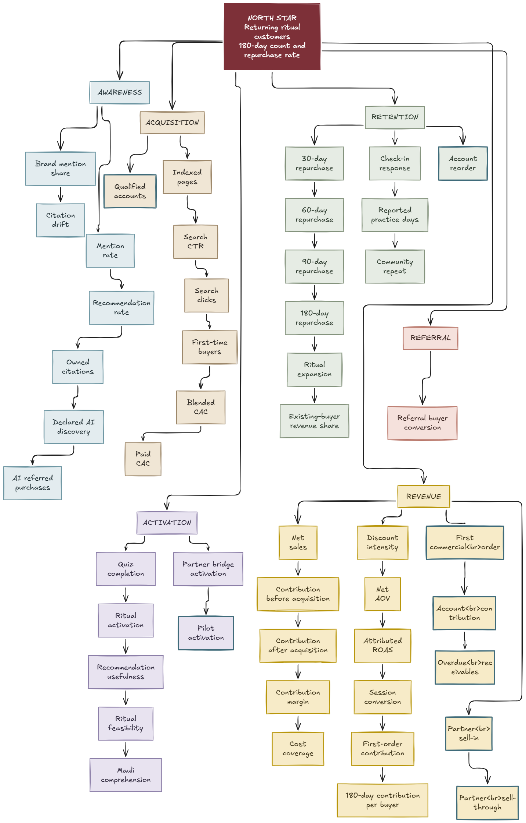
Figure C1. Proposed measurement hierarchy. Connections show how measures are organised; causal effects are assessed through the pilot design.
Stage | Measurement focus
Acquisition | Track first-time buyers and acquisition cost across paid media, social, search, observable AI referrals and partners. Assess SEO clicks and AEO/GEO mention, citation and accuracy separately.
Activation | Record a deliberate ritual save or selection, supported by usefulness feedback and quiz-to-purchase conversion. Compare text, voice and sound journeys on understanding, completion, purchase and service effort.
Retention | Use 90-day repurchase for the Ritual Profile pilot and 180-day repurchase for longer-term assessment. Report replenishment, ritual expansion, voluntary practice and community participation separately.
Referral | Follow introductions through first purchase and repeat purchase, separating customers, practitioners, creators, hospitality partners, affiliates and sponsors. Deduplicate the combined customer total.
Revenue | Report contribution after acquisition, first-order and repeat-order economics, and cohort payback. Include discounts, refunds, commissions and variable service costs, with setup and fixed costs shown separately.
Referral calculation. For a defined customer group and window, use observed buyer K-factor as referred first-time buyers divided by eligible senders. Add referred repeat buyers per sender after full follow-up. For commercial partners, report buyers, repeat buyers, contribution and service hours per active partner. These proposed definitions make V3’s referral approach operational.
Dashboard and accountability. Review journey performance weekly and reconciled contribution monthly, adding repurchase results as cohorts mature. Each headline measure carries its owner, period, source, numerator and denominator; customer and B2B account reporting remain separate.
Experiment discipline. Give each pilot one primary outcome, a defined comparison group, a fixed observation window and a consistent cost treatment. Retain original assignment when customers ignore the offer, and report uncertainty alongside the result.

C3. Evidence and assumptions
The supplied material reports £87 average order value, 61% D2C sales and a 46%/54% new-to-existing split. Retain these descriptions when presenting the current position; assess future retention through fully observed customer cohorts.
Label dashboard and model values reported, observed, modelled or proposed. Establish new operating benchmarks in month one and schedule 90-day and 180-day results when follow-up is complete. Retain unknown acquisition sources and show incomplete cost coverage explicitly.

Excel model
Accompanying workbook: Use the Excel model to test how acquisition cost, order value, repeat purchasing and costs affect contribution and payback. Scenario outputs follow the stated assumptions; observed performance is recorded separately.

Appendix D
Owned-Channel Economics and the Ritual Profile Pilot

D1. Where Mauli's margin is made
Table D1
Key Figures Behind the Resource Priority
Figure | Value | Source and note
Direct-to-consumer share of the business | 61% | Founder-stated (Mauli Rituals, 2026a, 2026b)
Returning customers | 54% of the new-to-returning split | Founder-stated. The split does not say whether it counts customers, orders or revenue
Average order value | £87, often above £100 | Founder-stated (Mauli Rituals, 2026a)
Share of marketing spend on Meta | About 72% | Founder-stated (Mauli Rituals, 2026b)
Meta return on ad spend | 2.57 (February 2024) to 1.56 (April 2026); acquisition cost up 31% | One agency, more than 230 brands (Common Thread Collective, 2026)
Effect of a 20% discount on an £87 basket | £17.40 removed before advertising cost | Team calculation
Space NK terms on an £87 sale | 65% margin and a 10% to 15% marketing contribution leave roughly £17 to £22 before product, packaging and logistics | Team calculation from quoted terms (Mauli Rituals, 2026b)
Newsletter open rate | 77%, against 30.5% average and 44.7% top 10% in Klaviyo's health and beauty benchmark | Apple Mail Privacy Protection inflates opens, so judge email on clicks and sales (Klaviyo, 2026; MarTech, n.d.)
Note. Figures about Mauli are founder-stated and unaudited. First-order contribution margin is not available.

D2. Evidence from comparable brands
- Automated email. In health and beauty, automated flows such as welcome, post-purchase and replenishment emails earn $2.09 in revenue per recipient against $0.32 for one-off campaigns, with a 4.8% click rate against 1.24% (Klaviyo, 2026). This is a vendor benchmark.
- Stitch Fix. Like Mauli, it asks new customers for detailed information first and uses it to personalise later contact. An investor's analysis reports an 83% repeat purchase rate in 2016 and 86% in 2017, and marketing at 3% and 7% of net revenue (Goodwater Capital, 2017). The figures rely partly on third-party estimates.
- Personalisation surveys. In a survey of 1,013 US consumers, 71% expected personalised interactions and 78% said personalised communication made them more likely to buy again. Both studies are self-reported (Arora et al., 2021).
- Limits of a retention-led plan. Brands grow mainly by gaining new buyers (Sharp, 2010), and passive loyalists can be poached (Court et al., 2009). With 46% of customers new, owned channels should make acquisition cheaper, not replace it.

D3. Ritual Profile pilot (90 days)
Mauli stores each customer's dosha and main concern from the quiz. It writes three short email journeys, one each for Vata, Pitta and Kapha, in Anita's voice: how to start, why it works, a technique video, a check-in and the natural next step. The final email is a reorder prompt timed to when the product runs out, with no discount. About 20% of eligible customers are held back as a control, because attribution is not the same as causation. The team tracks second-order rate, time to second order, quiz completion and unsubscribes. The new measure is ritual adoption rate: the share of buyers who buy a second step of their dosha ritual within 90 days. Mauli should scale if the profiled group out-buys the control at full price and the journeys need only a few hours a month, and stop if there is no measurable difference. The profile is optional, and customers who decline it still receive general Ayurvedic education. Email is requested after the quiz result, not before, under UK soft opt-in rules and with a privacy notice.

D4. How initiatives scored
Table D2
Initiative Scores From the Team's 12-Factor Assessment
Initiative | Score (of 60) | Verdict
Ritual Profile with CRM journeys | 54 | Prioritise
Partner-to-profile QR bridge | 46 | Test cheaply now
Therapist network (lean) | 45 | Test demand now, build next
Replenishment or subscription | 44 | Next
Customer-facing AI concierge | 34 | Next, after the data exists
Scaled Meta spend | 34 | Avoid
AR, app, VR | 27, 20, 16 | Avoid for now
Note. Fourteen initiatives were scored on 12 factors from 1 to 5. The scores are informed judgements, not measurements, and the order matters more than the exact numbers.

D5. Client data request
- Payback. How many orders does it take for a new customer to become profitable once discounts and Meta costs are included?
- Repeat at full price. What share of first-time customers buy again, and do those acquired during the two sale events return at full price?
- Owned channels. What share of D2C sales comes from the newsletter, Instagram and dosha-questionnaire users?
- Capacity. Who manages D2C, email and CRM day to day, and how much capacity do they have for something new?
Baselines are also needed for quiz completions, ritual share of orders, email list size and first-order sources.

Appendix E
Therapist Replenishment Pilot (Q6)
Anita reported that at-home therapists repeatedly ask to buy Mauli products for treatments. This is reported interest, not a measured conversion rate or a commitment to pay. The brand deck already shows a professional foundation: 16 treatments, massage oils for different mind-body types, salon sizes in parts of the range, account support, product training and founder masterclasses (Mauli Rituals, 2026a). It does not disclose therapist demand, trade prices, product costs or treatment dosage.

E1. Programme benchmarks
Table E1
Professional Programmes Used as Benchmarks
Programme | What it advertises | Use for Mauli
Botanicals | A separate account for smaller, home-based and mobile therapists with no start-up fee and low minimum orders. Free mainland UK express shipping above £200 including VAT, and a £500 threshold for salon and spa accounts (Botanicals, n.d.) | Separate small practices from larger spas, and design tiers with delivery cost in mind
Eve Taylor | Free online training and support, and no ongoing minimum order after joining. The trade price list is released after manual checks of a qualification certificate and business liability insurance (Eve Taylor, n.d.) | A precedent for checking suitability while making repeat orders easy
Art de Huile London | 20% off full-price products for eligible therapists, professional sizes, and approval in two to three business days (Art de Huile London, n.d.) | A price comparison only. It does not show that a 20% discount is affordable or needed
SKINTRUTH | 10% off subscriptions, delivery every four, eight or twelve weeks, no minimum term, and pause, skip or cancel options. Changing frequency or products requires a new subscription (SKINTRUTH, n.d.) | Flexibility is a design goal. It is not a therapist-only vetted scheme
Neal's Yard Remedies, FHT, BABTAC | A two-year practitioner card that needs a current insurance certificate for renewal (Neal's Yard Remedies, n.d.). FHT's register includes members with qualifications and insurance (Federation of Holistic Therapists, 2023). BABTAC offers membership with or without insurance (British Association of Beauty Therapy & Cosmetology, n.d.) | Verify at entry and again at renewal. Membership alone does not prove current cover
Note. Benchmarks describe advertised terms, not independent proof of commercial success.

E2. Design
- Journey. Therapist application, qualification and insurance checks, ritual training, product selection, automated replenishment and continued participation. AI may extract document details or flag missing information, and a person verifies suitability.
- Replenishment, not a discovery box. Therapists choose products, quantities and intervals, and can change, skip, pause or cancel. Among replenishment subscribers in a US survey of 5,093 respondents, convenience (24%), value for money (23%) and personalisation (22%) were the top reasons for staying (McKinsey & Company, 2018).
- Start with what is used up. Assess massage oils and frequently used facial products first, using existing therapist orders. Offer durable Kansa tools as first or occasional purchases, not routine replenishment.
- Price for contribution. Net sales excluding VAT, minus product cost, fulfilment, delivery subsidy, payment charges and support costs, gives contribution. Cost per treatment equals pack price divided by usable volume, multiplied by volume used per treatment. Tiers follow volume and cost to serve, with the same quality standards in every tier. Exact prices wait for Mauli's cost and margin data.
- Check the platform. Shopify lists subscriptions as incompatible with its native B2B features (Shopify, n.d.), while a vendor documents a WooCommerce route (Wholesale Suite, n.d.). Mauli should confirm its platform and plan before choosing tools, and test renewal prices, quantity changes, failed payments and expired approvals.

E3. Pilot and measures
Recruit a manageable cohort from therapists who have already expressed interest, and run long enough to see scheduled renewals at each delivery interval. Before launch, ask which products and sizes they need, treatment volume, current ordering intervals, acceptable prices and reasons for wanting a subscription. Measures: subscription conversion (paying subscribers divided by approved therapists offered the programme); scheduled renewal success; contribution per therapist; administration time per application and per order; supply reliability (orders complete and on time); and incremental contribution against the same therapists' earlier purchases. Moving existing orders into subscriptions may add convenience without adding sales, so growth targets wait for a baseline.
Left out of phase one: a public therapist-booking marketplace, compulsory paid membership and fully automated therapist approval.

Appendix F
Community and Instagram Evidence (Q7)
Anita questions whether Mauli's large Instagram audience is a community. The question is how to convert existing attention into participation, relationships and, later, revenue.
Table F1
Instagram Figures Used in the Diagnosis
Measure | Figure
Followers | About 36,000 rising to about 105,000 in a year
Typical reach of Mauli's own reels | Median of about 2,500 people, the same as before the growth
Concentration of views | 93% of 69 million reel views came from 20 reels; none of the 18 most viewed was a product post
Best reel | About 13 million views
Emotional content | "Hopecore Part 2": about 13.4K likes and 498 comments; "Age Is Just a Number": about 6.4K likes and 171 comments
Product and seasonal posts | Some below 50 likes
Note. Source: Mauli Rituals team (2026b). The date range and export behind these figures were not recorded in the team document, so they are directional until the export is attached.

F1. Interpretation
Mauli has two separate content engines. The reach engine runs on emotion, hope, ageing, confidence and human stories. The sales engine runs on products, ingredients and rituals. They are not connected strongly enough, so a viral reel is remembered without the brand. The link to build is emotion, then Ayurveda, then Mauli, then ritual, then participation and purchase.

F2. Recurring formats
- Ayurveda Did It First. A modern wellness trend is the hook, and the post shows its Ayurvedic roots.
- Return to Self. Keep the emotional content that earns reach, and make the Mauli, Ayurveda and ritual association clear in every high-reach piece.
- Ask Anita. Anita answers one community question each week, reacts to wellness trends and explains traditions she grew up with. Founder-led content is currently one of the most underused assets.
- Practitioner rituals. Verified practitioners demonstrate rituals, answer questions and host guided sessions, which lets Mauli scale the human touch beyond Anita and the internal team. This links to Appendix E.
- Proof of practice. More customer routines, testimonials from real customers, user content and expert recommendations, because branding creates interest and proof creates trust.

F3. Journey and measure
The journey is a high-reach post, then the Mauli profile, the ritual or dosha quiz, recurring participation, interaction with Mauli or a practitioner, and then repeat purchase and referral. Success is measured by the Ritual Participation Rate: the share of opted-in community members who complete at least two meaningful Mauli interactions within 30 days. Examples are answering a ritual prompt, completing the quiz, attending a live ritual, joining a practitioner session, sharing their own ritual or returning for another interaction. Supporting measures are shares, saves and comments per 1,000 views, quiz completion, repeat participation, user content and social-to-purchase conversion. Followers, likes and impressions are kept for diagnosis only.

Appendix G
Full Scorecard and 12-Month Roadmap (Q5)
Anita's warning that the metrics used in the next ten years might not work is already visible in Mauli's own data: followers tripled while the reach of its own posts did not move, and a customer can now be created by an AI recommendation, a quiz result or a practitioner's treatment without a single like or follower. The scorecard follows the customer through the new journey, and every metric should still work when a customer never sees an Instagram post.
Table G1
Full Mauli Ritual Scorecard
Stage | Metric | What it tells Mauli | Today
Found | Share of AI answers | How often assistants recommend Mauli for category questions | Named in 2 of 8 category-discovery answers (Appendix B)
Found | Orders from AI assistants | Whether AI recommendations turn into sales | Needs client data
Described | Answer accuracy | Whether AI describes rituals, ingredients and prices correctly | Gemini: unsupported claim or error in 7 of 10 answers. ChatGPT: 1 of 10
Described | Machine-readable proof | How many products carry dosha and ritual steps in their product data | The store files agents read are generic Shopify text (Appendix A)
Chosen | Quiz-to-order rate | Whether personalisation turns into purchases | Needs client data
Chosen | Full-ritual orders | Share of orders with two or more steps of one ritual | Needs client data. Average order £87
Chosen | Full-price share | Share of revenue sold without a discount, which matters as AI compares offers | Needs client data. 20% September sale and Black Friday offers
Kept | Repeat rate | Whether customers come back | 54% (founder-stated)
Kept | Value by first channel | Which entry point (AI, spa, Space NK, Instagram) brings customers who stay | Needs client data
Carried | Therapist sales | Active therapists using Mauli and the orders they generate | Network size needs client data
Carried | Where first orders come from | Share of new customers arriving through AI, spa, therapist, friend or gift, or social | Team count of reviews: friend, gift or spa credited 95 times and Instagram 5 times (method not recorded)
Note. Reporting stops treating follower count, likes, total views and raw website traffic as goals. They stay as diagnostics. Pew Research Center (2025) found that people clicked a regular link in 8% of visits when Google showed an AI summary, against 15% without one, which is why click-based measures will miss more of the journey.
Table G2
Twelve-Month Roadmap
Phase | What Mauli does | Metrics it moves
Months 0 to 3: foundations | Set baselines from client data. Run a claims audit and create an approved-claims file. Correct the product feed and prices. Connect the quiz to live stock and add a privacy note. Start the monthly AI check. Launch a weekly Ask Anita. Make sure every high-reach post carries a clear Mauli link. | AI accuracy, sold-out recommendations, participation (start)
Months 3 to 6: make the ritual readable | Publish ritual pages with structured data. Add AI-written quiz explanations from an approved phrase bank, reviewed weekly. Run the Ritual Profile pilot. Launch recurring community formats. Pilot verified practitioners and the therapist replenishment test. | Generic AI visibility, quiz-to-ritual purchase rate, participation
Months 6 to 12: scale the human touch | Practitioner-led rituals and live sessions. A guided newcomer conversation built from the customer question log. Move budget away from formats and channels that do not move the scorecard. | Repeat rate, returning ritual customers

G1. Supporting diagnostics and running the scorecard
- Diagnostics. Full-price share of revenue; customer value by first channel; where first orders come from; practitioner-led orders; the share of AI-written explanations that get edited and the number of questions handed to a person; and followers, likes, views and traffic, kept for diagnosis only.
- Cadence and sources. A one-page scorecard each month, reviewed with Anita, with decisions each quarter. Sources are Shopify (orders, repeat rate, full-price share, first channel), the quiz tool, practitioner codes and the monthly AI check, which takes about an hour by hand.
- No metric, no budget. Any technology or channel must name the headline metric it will move, and by how much, before it gets money or time. This is how a small team says no.

References
Link to the Project Website

Akter, S., & Fosso Wamba, S. (2016). Big data analytics in e-commerce: A systematic review and agenda for future research. Electronic Markets, 26, 173–194. https://doi.org/10.1007/s12525-016-0219-0
Arora, N., Ensslen, D., Fiedler, L., Liu, W. W., Robinson, K., Stein, E., & Schüler, G. (2021). The value of getting personalization right—or wrong—is multiplying. McKinsey & Company. https://www.mckinsey.com/capabilities/growth-marketing-and-sales/our-insights/the-value-of-getting-personalization-right-or-wrong-is-multiplying
Art de Huile London. (n.d.). Wholesale aromatherapy and therapist discounts. https://www.artdehuile.co.uk/pages/wholesale
Bommaraju, R., & Hohenberg, S. (2018). Self-selected sales incentives: Evidence of their effectiveness, persistence, durability, and underlying mechanisms. Journal of Marketing, 82(5), 106–124. https://doi.org/10.1509/jm.17.0002
Botanicals. (n.d.). Professional accounts. https://botanicals.co.uk/professional-accounts/
British Association of Beauty Therapy & Cosmetology. (n.d.). About BABTAC. https://www.babtac.com/about
Common Thread Collective. (2026). Meta CPMs are about to spike: Here's your 6-week window to get ahead. https://commonthreadco.com/blogs/coachs-corner/meta-cpms-are-about-to-spike-heres-your-6-week-window-to-get-ahead
Composio. (n.d.). TypeSafe Jev guide: How it works and six practical use cases. https://composio.dev/blog/typesafe-jev-guide-and-best-practical-usecases
Court, D., Elzinga, D., Mulder, S., & Vetvik, O. J. (2009). The consumer decision journey. McKinsey Quarterly, (3). https://www.mckinsey.com/capabilities/growth-marketing-and-sales/our-insights/the-consumer-decision-journey
CTPA. (2026, April 30). ASA ruling on misleading "clinically proven" claim. https://www.ctpa.org.uk/news/asa-ruling-on-misleading-clinically-proven-claim-9013
eesel. (n.d.). OpenAI Decisions API: What it is, how it works, and what's new. https://www.eesel.ai/blog/openai-decisions-api
Eve Taylor. (n.d.). Join Eve Taylor. https://joinevetaylor.co.uk/
Federation of Holistic Therapists. (2023, April 5). Making the most out of your FHT membership. https://blog.fht.org.uk/2023/04/05/making-the-most-out-of-your-fht-membership/
Future of Commerce course materials. (2026a). Week 2: Consumer behaviour and AI-personalised shopping [Slide deck]. Hult International Business School. Unpublished.
Future of Commerce course materials. (2026b). From SEO to AEO/GEO: Deep dive [Slide deck]. Hult International Business School. Unpublished.
Future of Commerce course materials. (2026c). Senses in the AI world [Slide deck]. Hult International Business School. Unpublished.
Future of Commerce course materials. (2026d). Client challenge discussion: Mauli Rituals [Slide deck]. Hult International Business School. Unpublished.
Goodwater Capital. (2017, November 13). Understanding Stitch Fix: Finding the perfect fit [Investment thesis]. https://www.goodwatercap.com/perspectives/understanding-stitch-fix
Google for Developers. (n.d.). Deprecation and sunset: Content API for Shopping. https://developers.google.com/shopping-content/guides/deprecation-and-sunset
Gowling WLG. (2026). Misleading sales practices: Don't sleep on the CMA. https://gowlingwlg.com/fr/insights-resources/articles/2026/misleading-sales-practices-dont-sleep-on-the-cma
InfoQ. (2026, October). Cloudflare's Clef decision models [News article]. https://infoq.com/news/2026/10/clef-decision-models
Klaviyo. (2026). Email marketing benchmarks: Health and beauty [Benchmark report]. https://www.klaviyo.com/uk/products/email-marketing/benchmarks
Lemon, K. N., & Verhoef, P. C. (2016). Understanding customer experience throughout the customer journey. Journal of Marketing, 80(6), 69–96. https://doi.org/10.1509/jm.15.0420
Let's Data Science. (2026, June 15). Google's Mueller rejects llms.txt for discovery. https://letsdatascience.com/news/googles-mueller-rejects-llmstxt-for-discovery-55ef5aaa
Luo, X., Tong, S., Fang, Z., & Qu, Z. (2019). Frontiers: Machines vs. humans: The impact of artificial intelligence chatbot disclosure on customer purchases. Marketing Science, 38(6), 937–947. https://doi.org/10.1287/mksc.2019.1192
MarTech. (n.d.). Study finds iOS 15 is inflating email open rates. https://martech.org/study-finds-ios-15-is-inflating-email-open-rates/
Mauli Rituals. (n.d.). Home page. Retrieved October 8, 2026, from https://www.maulirituals.com
Mauli Rituals. (2026a). Mauli retailer deck [Unpublished client document, August 2026].
Mauli Rituals. (2026b). Client Q&A with Anita Kaushal [Video recording, 42 minutes]. Unpublished.
Mauli Rituals team. (2026a). AI assistant audit [Unpublished raw data].
Mauli Rituals team. (2026b). Instagram content analysis [Unpublished raw data].
Mauli Rituals team. (2026c). Quiz comparison: Harry Potter house quiz and Mauli Ritual Builder [Video recordings]. Unpublished.
Mauli Rituals team. (2026d). Ritual Builder walkthrough, 6 October 2026 [Unpublished screenshots].
McKinsey & Company. (2018, February 9). Thinking inside the subscription box: New research on e-commerce consumers. https://www.mckinsey.com/industries/technology-media-and-telecommunications/our-insights/thinking-inside-the-subscription-box-new-research-on-ecommerce-consumers
McKinsey & Company. (2025, October 17). The agentic commerce opportunity: How AI agents are ushering in a new era for consumers and merchants. https://www.mckinsey.com/capabilities/quantumblack/our-insights/the-agentic-commerce-opportunity-how-ai-agents-are-ushering-in-a-new-era-for-consumers-and-merchants
Modern Retail. (2026, March 12). Shopify says purchases are coming inside ChatGPT through agentic storefronts as OpenAI retreats on Instant Checkout. https://www.modernretail.co/technology/shopify-says-purchases-are-coming-inside-chatgpt-through-agentic-storefronts-as-openai-retreats-on-instant-checkout/
Neal's Yard Remedies. (n.d.). Help centre. https://www.nealsyardremedies.com/pages/faq
Oswald, L. R. (1999). Culture swapping: Consumption and the ethnogenesis of middle-class Haitian immigrants. Journal of Consumer Research, 25(4), 303–318. https://doi.org/10.1086/209541
Pauwels, K., Ambler, T., Clark, B. H., LaPointe, P., Reibstein, D., Skiera, B., Wierenga, B., & Wiesel, T. (2009). Dashboards as a service: Why, what, how, and what research is needed? Journal of Service Research, 12(2), 175–189. https://doi.org/10.1177/1094670509344213
Peck, J., & Childers, T. L. (2003). To have and to hold: The influence of haptic information on product judgments. Journal of Marketing, 67(2), 35–48. https://doi.org/10.1509/jmkg.67.2.35.18612
Pew Research Center. (2025, July 22). Google users are less likely to click on links when an AI summary appears in the results. https://www.pewresearch.org/short-reads/2025/07/22/google-users-are-less-likely-to-click-on-links-when-an-ai-summary-appears-in-the-results/
Rao, B., Chhangani, J., Navlakha, P., Jose, P. C., Maheshwari, N., Avinash, A., Paliwal, R., & Zeeshan Khan, M. (2026). Marketing analytics and decision-making: A review of data-driven approaches in management practices. Academy of Marketing Studies Journal, 30(1), 1–10. https://www.abacademies.org/articles/marketing-analytics-and-decisionmaking-a-review-of-datadriven-approaches-in-management-practices-17752.html
Roy, S. K., Tehrani, A. N., Pandit, A., Apostolidis, C., & Ray, S. (2025). AI-capable relationship marketing: Shaping the future of customer relationships. Journal of Business Research, 192, 115309. https://doi.org/10.1016/j.jbusres.2025.115309
Sharp, B. (2010). How brands grow: What marketers don't know. Oxford University Press.
Shopify. (n.d.). Requirements and considerations for using B2B. https://help.shopify.com/en/manual/b2b/getting-started/considerations
Shopify. (2026). Shopify Editions | Spring '26. https://www.shopify.com/editions/spring2026
SKINTRUTH. (n.d.). Subscription. https://www.skintruth.co.uk/pages/subscription
Timoumi, A., Gangwar, M., & Mantrala, M. K. (2022). Cross-channel effects of omnichannel retail marketing strategies: A review of extant data-driven research. Journal of Retailing, 98(1), 133–151. https://doi.org/10.1016/j.jretai.2022.02.008
Vapi. (n.d.). ElevenLabs voice provider. https://docs.vapi.ai/providers/voice/elevenlabs
Wholesale Suite. (n.d.). WooCommerce Subscriptions integration. https://wholesalesuiteplugin.com/integrations/woocommerce-subscriptions-integration/

Team Contributions and Use of AI

Question | Topic
Q1 Marcella | AI without losing the personal touch
Q2 KJ | Personalisation at scale
Q3 Olta | Where to execute with limited resources
Q4 Yasmim | Emerging technology for communication and retail
Q5 Sarp | New metrics
Q6 Zuzanna | Therapist community platform
Q7 Adar | Community over follower-counting

.

Academic Integrity & Technical Disclosure Statement

Policy Compliance Confirmation:
Submitting this work confirms that all team members have read and adhered to Hult’s Academic Integrity Policy, Professional Integrity Policy, Honor Code, and AI Policy.

Authorship, Accountability & Project Scope
Individual Ownership & Collective Comprehension: While submitted as a unified deliverable, primary ownership is partitioned by section. Given the interconnected scope of the project, each contributor takes individual responsibility for their specific sections, while maintaining a collective understanding and working grasp of the overall project.
Prohibition of Misconduct: Each member confirms this work is original. Plagiarism, unacknowledged third-party outsourcing, or unauthorized text generation are strictly prohibited; any compliance breaches remain the isolated responsibility of the actor involved.
Verification & Review: All members can independently substantiate their contributions. To validate mastery and rigorous standards, the team welcomes a structured Q&A or oral review format during presentations.

Summary of Research & Technical Infrastructure Used
In accordance with university policy - generative AI, automated agents, and specialized software were deployed strictly as extending auxiliary research and engineering tools. Core strategy and composition remain human-driven.
Research & Discovery: Consensus and Perplexity for literature/web sources; Google Notebook (including Deep Research and course material summaries) for netography and reference mapping.
Ideation & Modeling: ChatGPT, Claude, and Gemini for analytical sharpening and testing twin synthetic lenses (client and professor personas).
Engineering & Prototyping: Cursor development environment utilizing ChemiTree models, GPT Soul for code refinement, Leven Labs/Agents for workflow structures, and Shopify’s internal API for protocol analysis.
QA & Verification: Multi-agent verification (Cursor Bots and Claude Code Agents) for automated testing, with cross-model re-verification via ChatGPT, Claude, and Gemini.
Quantitative Extension: An Excel-based financial model mapping marketing strategies to unit economics and financial revenue line (operating as an adjunct supporting document).

Declaration: All final synthesis, technical architecture, and written composition are the original responsibility of the respective authors and the team.

